Exercises: Inheritance
Problems for exercise and homework for the Python OOP Course @SoftUni.
Submit your solutions in the SoftUni judge system at https://judge.softuni.bg/Contests/1941.

Person
You are asked to model an application for storing data about people. You should be able to have a Person and a Child. The child derives from the person. Every person receives name and age upon initialization. Your task is to model the application.
Create a Child class that inherits Person and has the same constructor definition. However, do not copy the code from the Person class - reuse the Person class's constructor.
Submit in judge a zip file named project, containing a separate file (person.py and child.py) for each of the classes.
Test Code | Output
person = Person("Peter", 25)  child = Child("Peter Junior", 5)  print(person.name)  print(person.age)  print(child.__class__.__bases__[0].__name__) | Peter  25  Person

Zoo
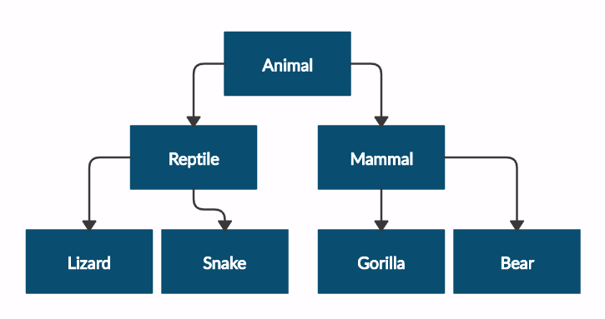
Create a zoo which contains the following classes:
Submit in judge a zip file of the project, containing a separate file for each of the classes using the structure shown below:
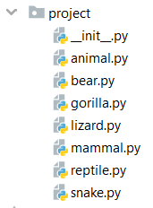
Follow the diagram and create all the classes. Each of them, except the Animal class, should inherit from another class as shown in the diagram. The Animal class should receive a name - string upon initialization.
Every class should have constructor, which accepts one parameter: name
Test Code | Output
mammal = Mammal("Stella")  print(mammal.__class__.__bases__[0].__name__)  print(mammal.name)  lizard = Lizard("John")  print(lizard.__class__.__bases__[0].__name__)  print(lizard.name) | Animal  Stella  Reptile  John

Players and Monsters
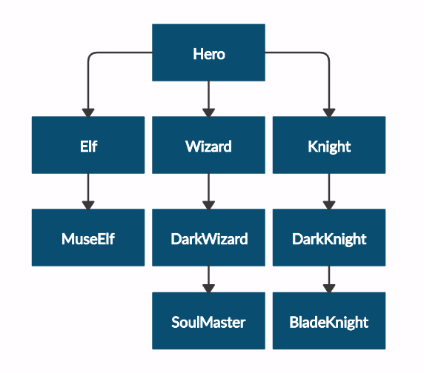
Your task is to create the following game hierarchy:

Submit in judge a zip file, containing a separate file for each of the classes using the structure shown below:
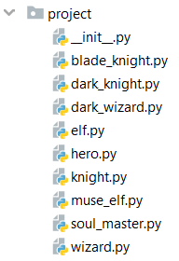
Create a class Hero. It should contain the following attributes:
- username - string
- level - int
Override the __str__() method of the base class so it returns: "{name} of type {class_name} has level {level}"

Test Code | Output
hero = Hero("H", 4)  print(hero.username)  print(hero.level)  print(str(hero))  elf = Elf("E", 4)  print(str(elf))  print(elf.__class__.__bases__[0].__name__)  print(elf.username)  print(elf.level) | H  4  H of type Hero has level 4  E of type Elf has level 4  Hero  E  4

Need for Speed
Create the following hierarchy with the following classes:
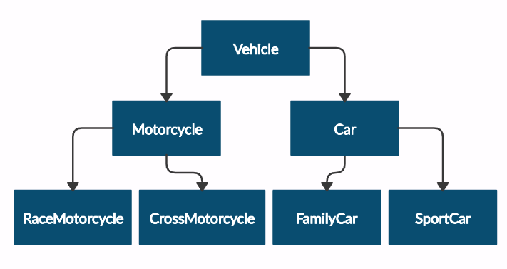
and submit in judge a zip file, containing a separate file for each of the classes using the structure shown below:
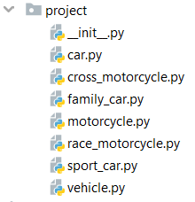
Create a base class Vehicle. It should contain the following attributes:
- DEFAULT_FUEL_CONSUMPTION: float (constant)
- fuel_consumption: float – the given fuel consumption is per kilometer
- fuel: float – represent the fuel in the specific vehicle
- horse_power: int
The class should recieve fuel and horse_power upon initialization and should set the default fuel consumption on the attribute fuel_consumption.
The class should have the following methods:
- drive(kilometers) - reduces the fuel based on the travelled kilometers and fuel consumption. Keep in mind that you can drive the vehicle only if you have enough fuel to finish the driving.
The default fuel consumption for Vehicle is 1.25. Some of the classes have different default fuel consumption:
- SportCar - 10
- RaceMotorcycle - 8
- Car - 3
Test Code | Output
vehicle = Vehicle(50, 150)  print(Vehicle.DEFAULT_FUEL_CONSUMPTION)  print(vehicle.fuel)  print(vehicle.horse_power)  print(vehicle.fuel_consumption)  vehicle.drive(100)  print(vehicle.fuel)  family_car = FamilyCar(150, 150)  family_car.drive(50)  print(family_car.fuel)  family_car.drive(50)  print(family_car.fuel)  print(family_car.__class__.__bases__[0].__name__) | 1.25  50  150  1.25  50  0  0  Car

Shop
Maria is expanding her business and today she is opening a grocery shop. You are hired to write a program which keeps track of the shop's inventory.
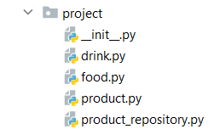
In the product.py file the class Product should be implemented. It is a base class for any type of food and drink.
The class should receive name: str and quantity: int upon initialization. It should also have two methods:
- decrease(quantity: int) – decreases the quantity of the product only if there is enough
- increase(quantity: int) – increases the quantity of the product with the given one
In the file drink.py the class Drink should be implemented. The class should inherit from the Product class. An instance of the Drink class will have name and quantity of 10.
In the food.py file the Food class should be implemented. The class should inherit from the Product class. An instance of the Food class will have name and quantity of 15.
In the product_repository.py file the class ProductRepository should be implemented. It is a repository for all the products that are delivered to the grocery shop.
The class should have products: list – empty list upon initialization that will contain all products (objects). Also, the class should have 3 instance methods:
- add(product: Product) - adds a product to the repository
- find(product_name: str) - returns a product (object) with that name
- remove(product_name) - removes a product from the repository
Override the __repr__ method, so it returns an information for all the products in the repository in the format:
"{product_name1}: {quantity1}"
"{product_name2}: {quantity2}"
...
"{product_nameN}: {quantityN}"

